|  |  |
| --- | --- |
| **Test Name** | Crown & Anchor Automated Test Bug 1 |
| **Use Case Tested:** | Automate the testing of errors in UAT Test 1 (for Bug 1) |
| **Test Description:** | Test that player’s balance does not increase when one match with the rolled dice occurs |
| **Pre-conditions** | Single player ‘Sally’ created  Each run to use a single dice value ‘CROWN’ as the player’s pick  Game will roll dice until 10 single matches are found |
| **Post-conditions** | n/a |
| **Notes:** | **An assert will determine if player’s balance has been increased in any of the single dice roll matches**  **Note this also tests the result of the player’s balance if two or more matches are occurring.**  **This test also shows Bug 4, which is that each roll in the same game produces the same three dice rolls.** |
| **Result (Pass/Fail/Warning/Incomplete)** | **1) Pass: When the game rolls three different dice and the player’s dice matches one of them, the balance does not change (does not increment nor decrement).**  **2) Fail: When the game rolls two of the same dice and one different (or all three the same) but the player’s dice does not match them, the balance decrements.**  **3) Fail/Incomplete: When the game rolls two or three of the same dice and the player’s dice matches them, the test runs in an endless loop and keeps incrementing player balance (this result is expected due to the nature of the test design).**  **4) Pass: When the game rolls three different dice and the player’s dice matches none of them, the game finds no match and the player’s balance is decremented and the program fails to achieve the 10 rolls as the limit is reached and an error message displayed.** |

# Screenshots for Results (by number of result)

1) Three different dice/match

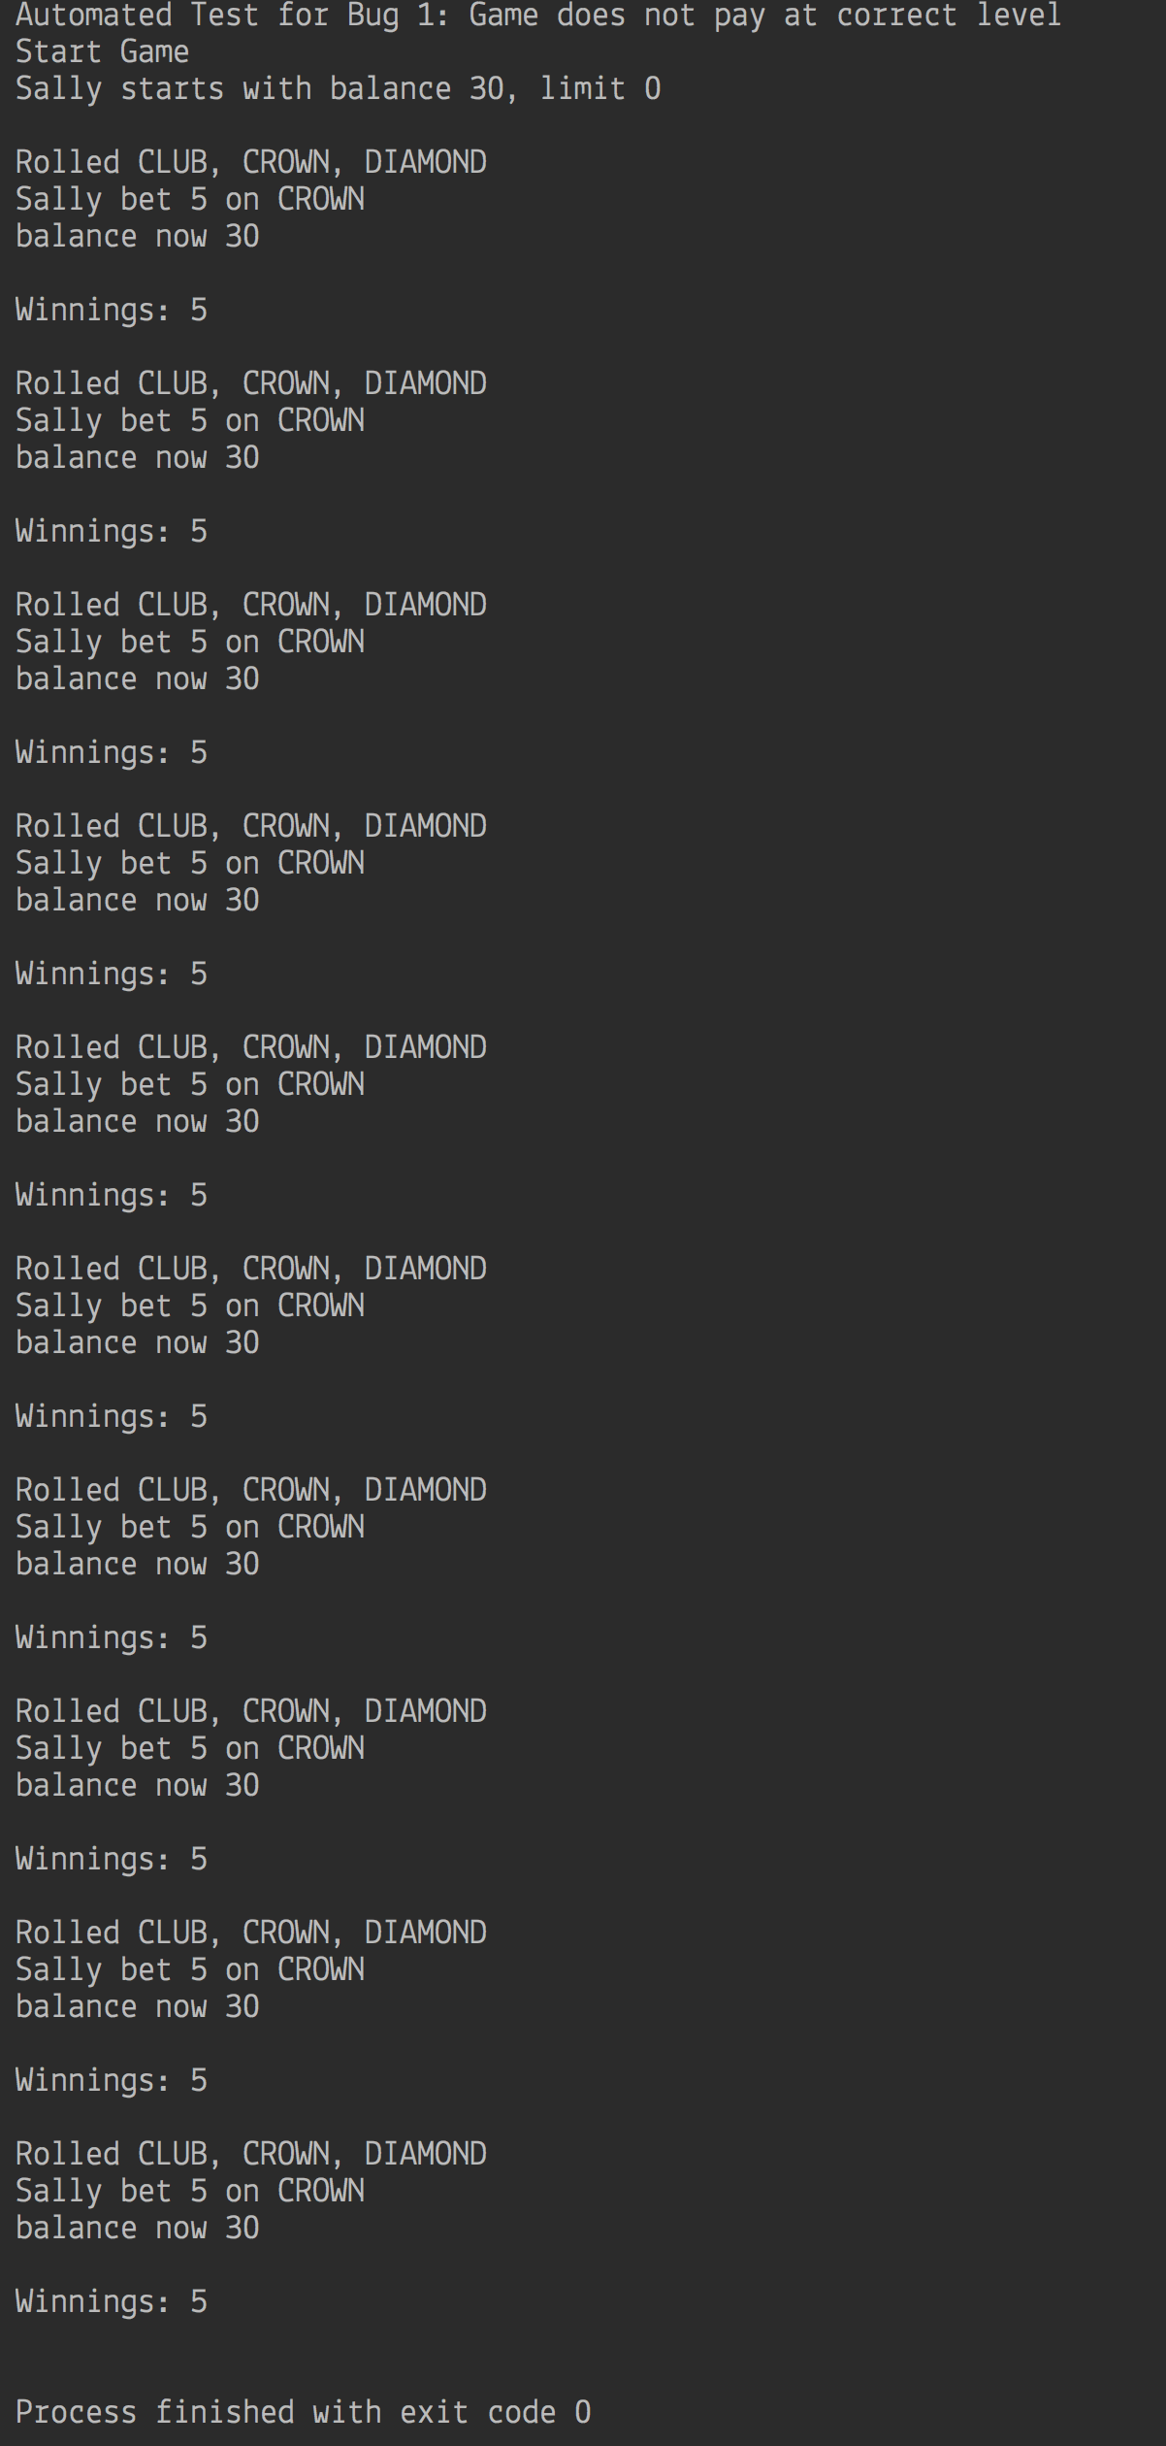

2)

Two dice the same/no match:

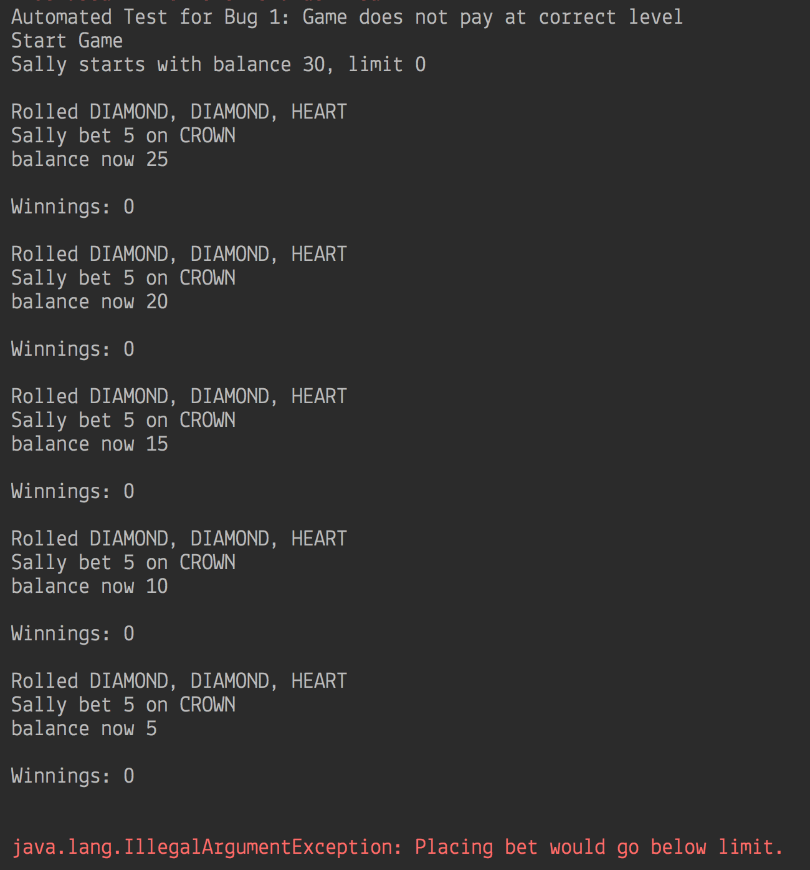

Three dice the same/no match:

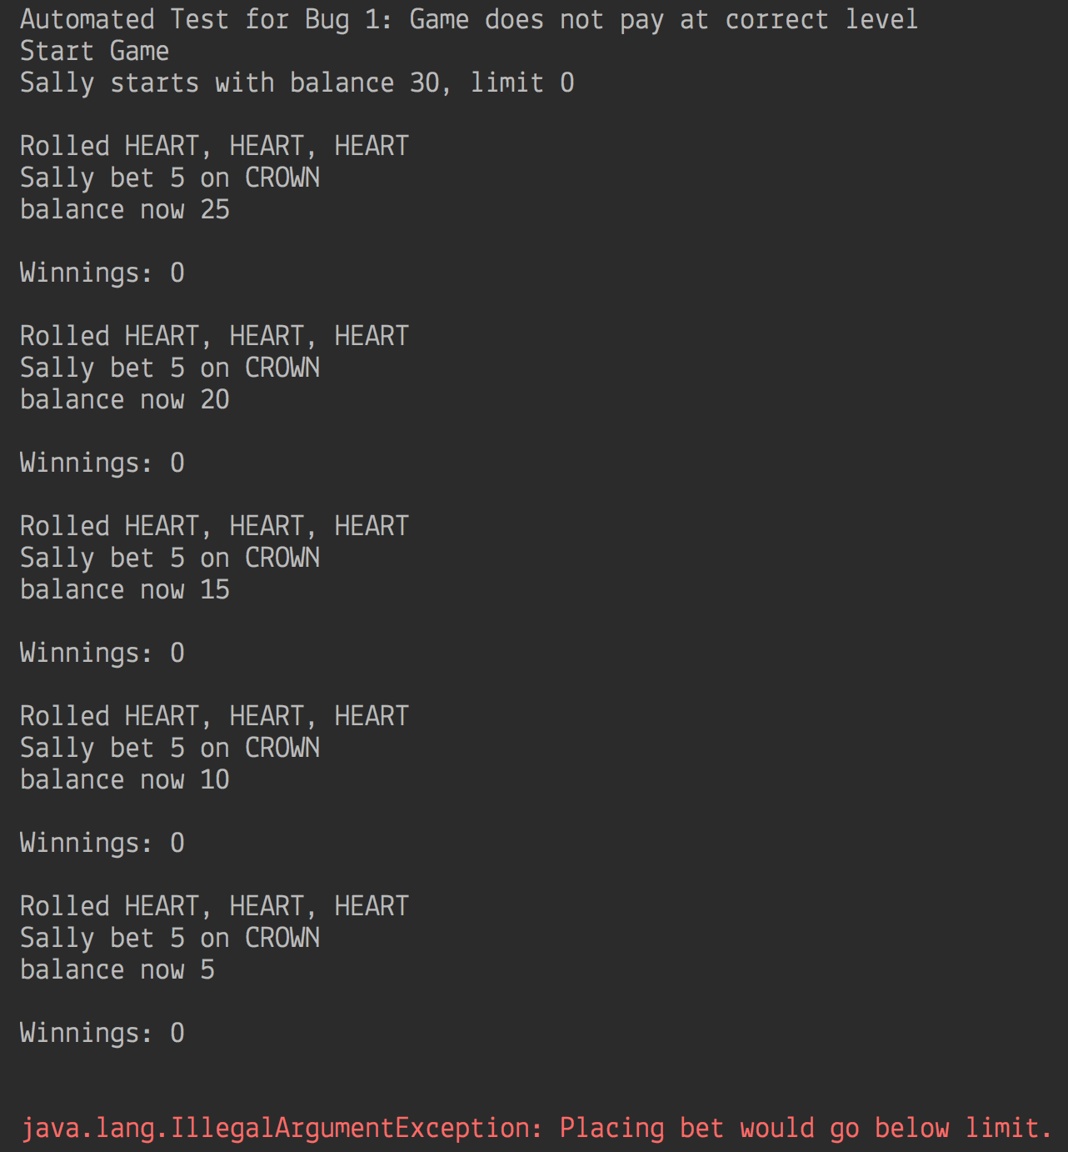

3) Two or more dice the same/match:

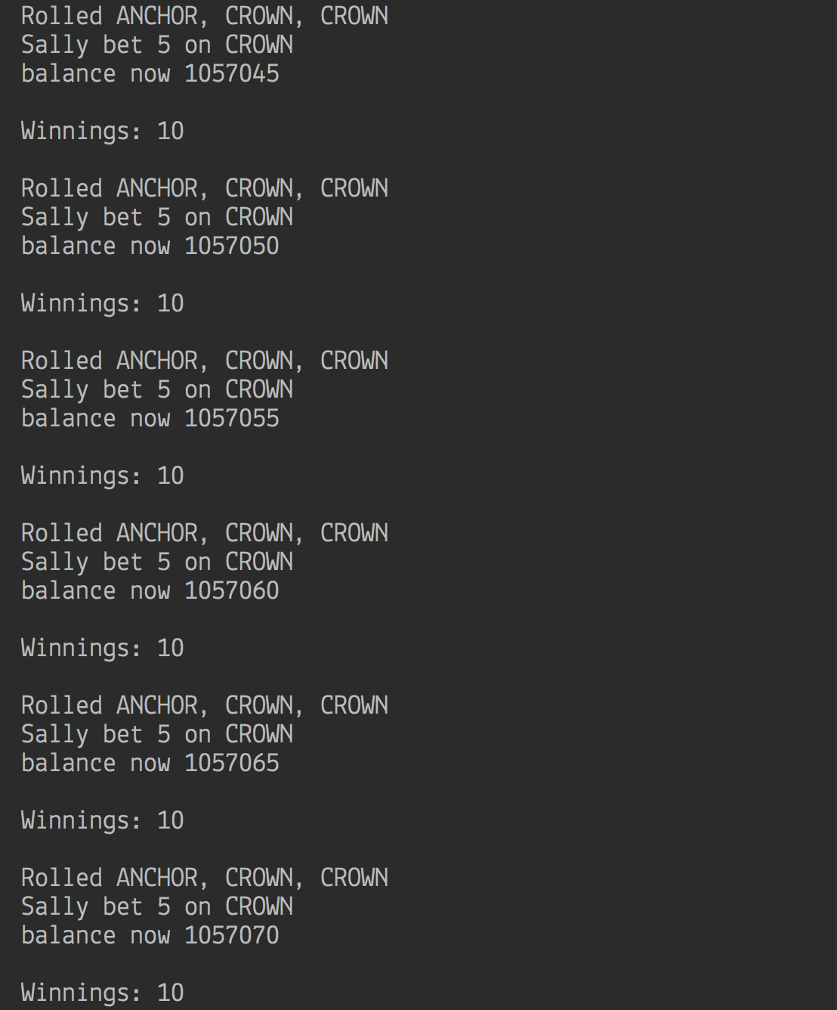

4) Three difference dice/no match:

